# Teaching Rubik’ Site Plan

## Kryton Bess

## WDD 130

## Overview

### Purpose

Teaching the 2 different ways to solve a rubik’s cube

### Audience

Anyone interested in learning how to solve a rubik’s cube

## Branding

### Website Logo



## Style Guide

### Color Palette

| **Primary** | **Secondary** | **Accent 1** | **Accent 2** |
| --- | --- | --- | --- |
| #0046AD | #023047 | #b71234 | #ff5800 |

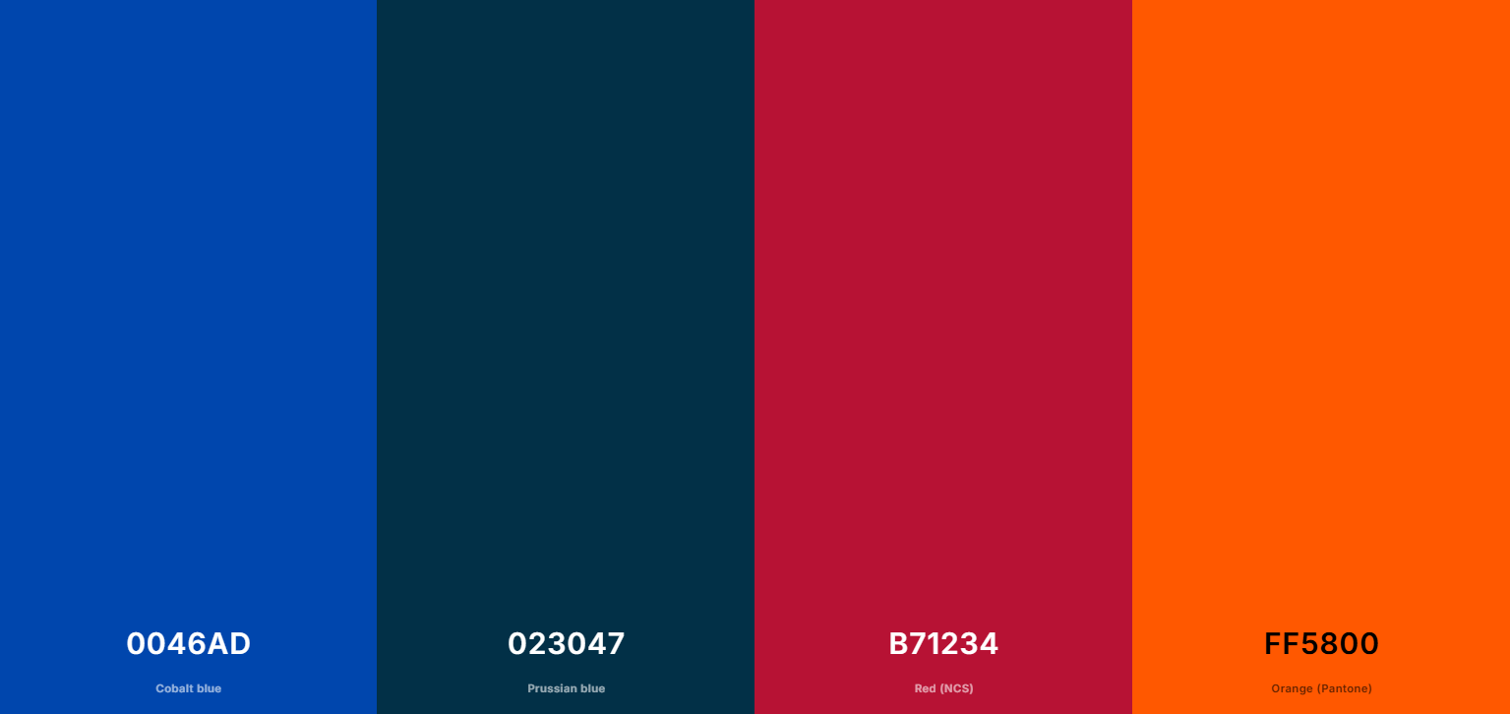

### Typography

#### Heading Font: [Font Name here]

#### Paragraph Font: [Font Name here]

### Navigation

Home Method 1 Method 2

**Content**

Rubik’s Cube 101:

Before Starting

Before we start, you need to both understand cubing notation and get your cube to this point:

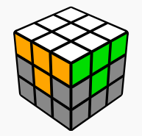

It is not required to use any formulas to get to this point, so you can do this by yourself. If you struggle or want help with it, here’s instructions, as well as instructions on cubing notation:

Cubing Notation

Solving The Top

----------------------------------------------

Solving The Middle!

Next up is the middle section. This is our goal:

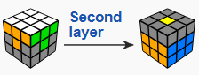

This is where we start being required to use algorithms but luckily there are only 2 and they’re very similar

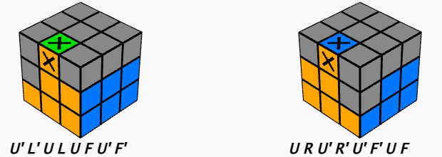

Note that if the section is in the right spot but reversed, you need to do one of the above to remove it and then get it in the correct spot

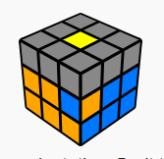

----------------------------------------------

Solving The Bottom!

Last but not least, we need to do the bottom section

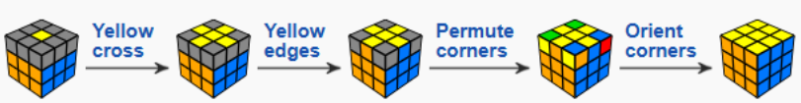

Starting with the cross, you need to follow this pattern. If you have just the center, do the formula 3 times. If you have the l shape, make it face the back and run it twice. With the line, just run it once. No need to worry about the side colors, we’ll do that next

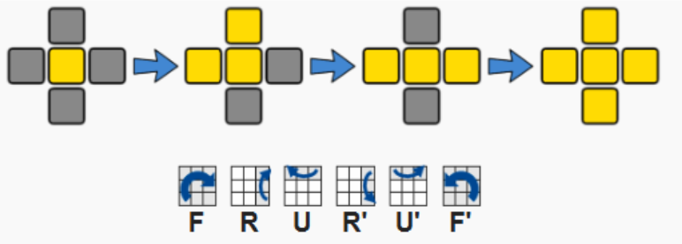

Now we’ll get the sides to be the correct colors. Running this formula will swap the 2 sections on the left (or in the front and on the left if you’re looking at it directly at the front)

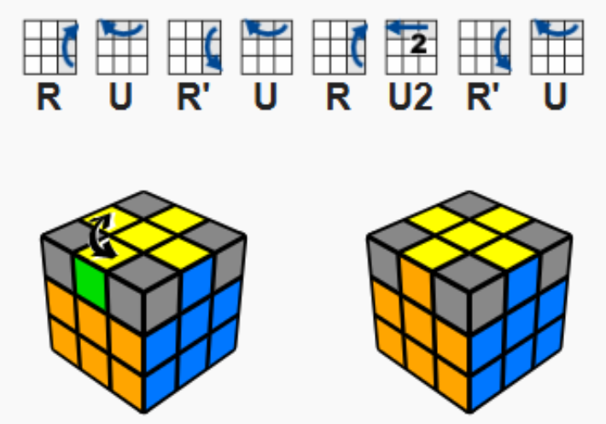

Once that is done, we need to get the corners into the right spots. Not the right orientation, just the right spots. Using this formula will rotate the 3 corners not in the top right

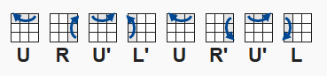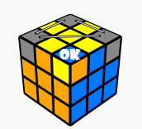

The last step is to rotate the corners into the correct orientation. Do this formula either 2 or 4 times until the current corner you’re working on is correct. Repeat for all four corners and you’re done!

- - - - - - - - - - - - - - - - - - - - - - - - - - - - - - - - - - - - - - - - - - - - - - - - - - - - - - - - - - - - - - - - - - -

Cubing Notation

Understanding cubic notation makes learning how to solve a rubik’s cube a lot easier.

This graphic shows the different movements you will make on the cube from the front perspective.

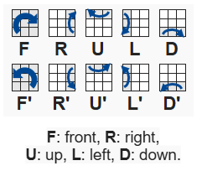

For Example, if the formula were “F R U”, this would be the sequence you would follow (with red being the front):



Also, in the images on this page, orange in the cube below would be considered the front, so “F” would twist a row of yellow down into the blue section

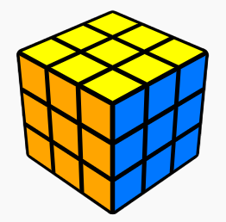

- - - - - - - - - - - - - - - - - - - - - - - - - - - - - - - - - - - - - - - - - - - - - - - - - - - - - - - - - - - - - - - - - - -

Solving the top!

First we need to get the top solved. This is what we’re trying to achieve in this section. Note that the sides should match the center side colors:

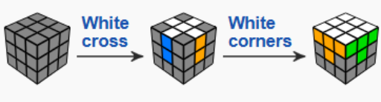

You can do this without any formulas but these are some to make things easier, match up your cube so that the piece you’re trying to get into place is in one of these locations, then use the formula

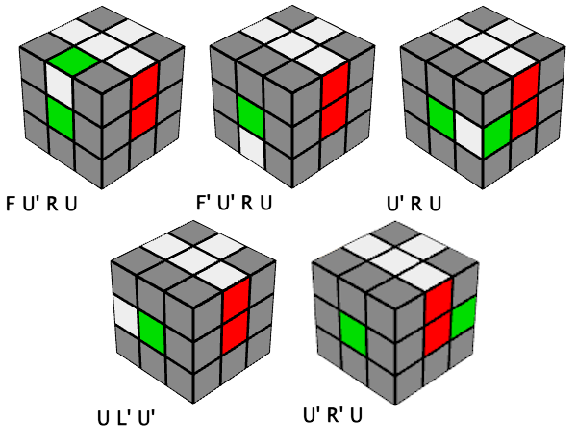

Once you have the cross, you can work on getting the corners into place. Once again, here are some formulas you can use, or you can just do it by yourself!

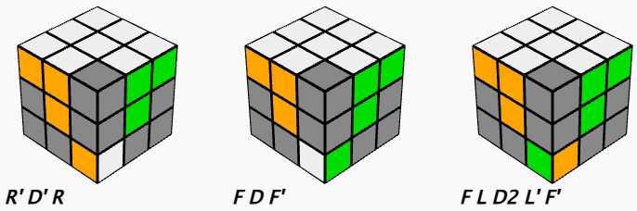

**Wireframes**

### Home

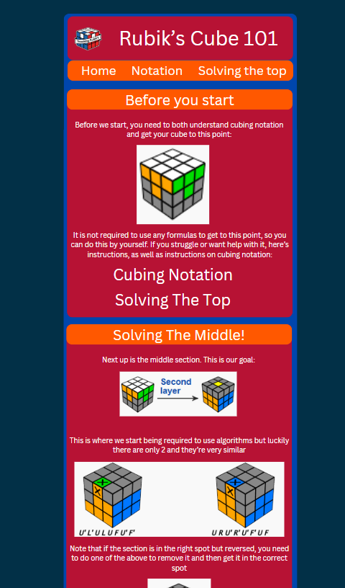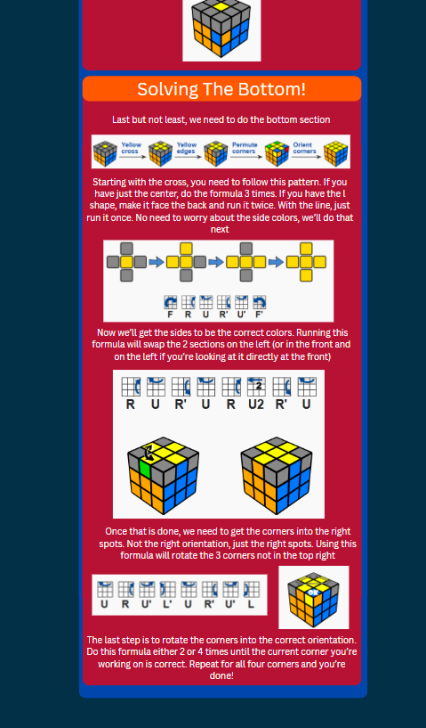

### 

### 

### Child 1 - Notation

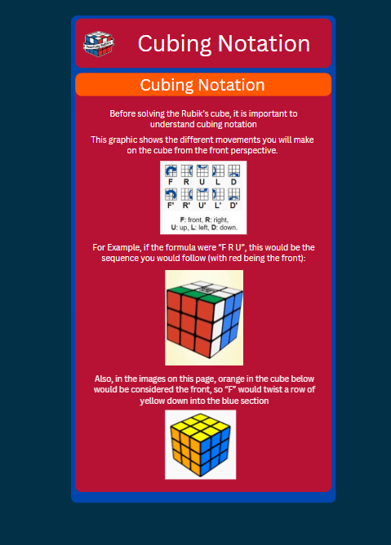

### 

### 

### 

### 

### 

### 

### 

### 

### 

### 

### 

### 

### 

### 

### 

### 

### 

### 

### Child 2 - Solving the Top

